Scarborough Community Legal Services
Annual Report 2016

MESSAGE FROM THE CHAIR
MERVIS WHITE

2016 has been another eventful year, full of changes, for our legal clinic. New staff has been hired, long term staff have retired, new services are now offered, the office has been renovated, we are developing a new management structure, and we have begun new collaborative projects with other legal clinics.

In 2015, after the provincial government raised the Financial Eligibility Guidelines for legal services, Legal Aid Ontario gave us additional funds to provide more services. We were able to hire three new legal staff. We can now provide more services in income maintenance and we are providing new services in employment law and immigration law. With more staff as well as the additional lawyers who come to our office weekly to provide family law and employment law services, we needed more space. We were able to renovate our existing space to provide four new private offices for legal staff plus new workstations for our support staff.

Last year at this time we had just begun a joint Environmental Scan with West Scarborough Community Legal Services to look at how the two clinics can co-operate with each other and with other agencies to provide more and better poverty law services. That project is nearing completion. We will use the findings from the scan to inform our strategic planning for the future.

We were part of a pilot project with the 6 community legal clinics east of Yonge Street to provide employment law services for the entire area. This included a lawyer coming to our office one day per week to augment the work of our own employment law lawyer and a community legal worker who co-ordinated outreach and community development. The group of six clinics has now received permanent funding for employment and immigration law staff. This collaborative service is crucial for us to be able to provide services in these new areas of law to people who live in our catchment area, because we only received enough funding of our own for one staff in each area of law.

Despite the additional funding we received, our clinic continues to be among the most under-resourced community legal clinics in the province. We hope to receive more funding in the next year.

The most significant change in the past year was the retirement of our Legal Director, Elizabeth Klassen. Before she left, the Board formed a Management Review Committee and is working with a consultant to develop a plan to change our management structure and hire an Executive Director. The Committee has completed its work on recommendations for changes and is still in the process of searching for the new ED.

Throughout these changes and challenges, the staff and board have worked to continue to serve people who need help with their poverty law problems.

STAFF REPORTS

EMPLOYMENT TEAM
Sarah Charow -Staff Lawyer

CASEWORK

Scarborough Community Legal Services has been extremely busy building up our emerging employment law practice. Our practice is currently a fairly even mix of Employment Insurance, Employment Standards, wrongful dismissals, and human rights cases. We are also assembling templates, standard letters, and forms for office use to increase our practice’s efficiency. We are active participants in the Workers’ Rights Action Group and the Employment Insurance Working Group and have acted as a resource to local student legal aid clinics, Community Legal Education Ontario, and other Toronto East Employment Law Services (“TEELS”) clinic staff.

COMMUNITY DEVELOPMENT, OUTREACH, AND LAW REFORM

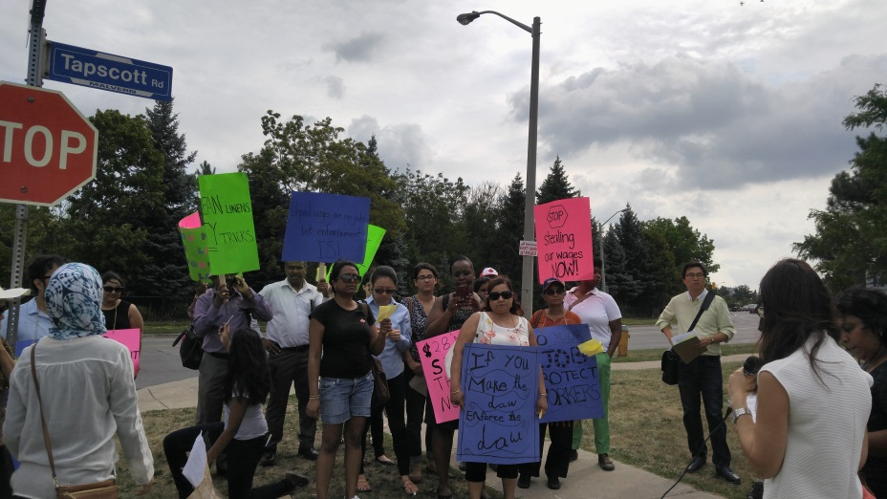
From a community development perspective, we have enjoyed getting out into the community and meaningfully engaging in hands-on advocacy work. Scarborough Community Legal Services was heavily involved with planning and participating in the TEELS Day of Action on August 12, 2016. This day of action was a three-stop bus tour designed to protest the lack of enforcement of Ontario’s workplace laws. We visited an employer who had multiple employment standards violations, the local Ministry of Labour, as well as the office of one of our local MPPs, and passionately demanded stronger workplace laws that actually protect workers.

We continue to provide quality public legal education throughout the Scarborough community, with sessions at the Family Residence, the TEQ LIP’s Employment Education Action Group, the YMCA Youth Job Connection program, Tropicana Community Services, the YWCA JUMP program, the Afghan Women’s Organization, JVS, and a joint program for frontline staff with West Scarborough Community Legal Services.

Our outreach efforts have been largely tied to our extensive public legal education work, but we have also been actively reaching out to our Scarborough community. We have attended meetings with various community partners to discuss how to best serve the employment law needs of our catchment area, as well as to figure out how to offer services in collaboration with other service providers. We have attended agency fairs at local schools and community centres that have been focused on educating people about our services, with a special focus on our new employment law services.

We have also sought to increase our online presences by using social media to reach out to people in our community and agencies in our field. We “tweet” about news stories, legislative developments, and SCLS’s own activities.

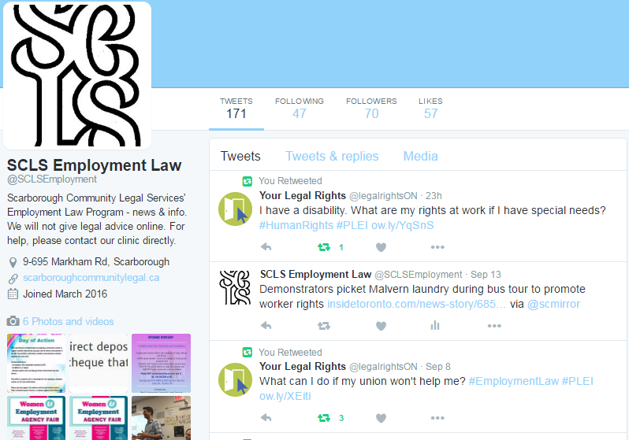
Our Twitter feed has also proven to be a useful networking tool – through it we are connected to other service providers, community groups, politicians, and even other community legal clinics across the province. This is a great way to see what other organizations have achieved, as well as share our own successes with our peers and the community in general.

Regarding law reform, our clinic had been asked to participate in a working group designed to advocate for changes to be made by the Social Security Tribunal (“the SST”), the administrative body that adjudicates Employment Insurance, CPP, and Old Age Security appeals. In June, I, along with other clinic advocates from across the province, met with Murielle Brazeau, the Chair of the SST. We shared our experiences with the SST, and discussed the tribunal’s strengths and weaknesses. In particular, we focused on issues with the tribunal’s communication policies, disclosure of the appeal file, location of hearings, and publication of previous decisions.

Our working group also advocated for a formalized stakeholder process, similar to the types of processes used by the Social Justice Tribunals in Ontario, the creation of a position at the SST (a dedicated person that clinic caseworkers can contact at the SST) and for the SST to consider a model where there is a particular person at the SST responsible for the file to whom we can direct questions or raise issues.

IMMIGRATION TEAM
Barbara Leiterman -Staff Lawyer

We started to offer immigration law services in March 2016. Our first task was to determine our case selection priorities and provide training to our intake and support staff.

CASEWORK

Humanitarian and Compassionate Applications

There is a high demand for Humanitarian and Compassionate (H&C) applications in our catchment area. H&Cs enable people who would not normally be eligible to become permanent residents of Canada to apply for permanent residence from within Canada based on humanitarian grounds. H&C applications are assessed based on how established the person is in Canada - their general family ties to Canada, the best interests of any children involved and what could happen to the applicant if the request is not granted.
We assist clients by filing H&C applications and providing advice and brief services on how to build a meritorious H&C application. We monitor H&C case law and regulatory developments
and refine our H&C submissions accordingly.
Challenging Family Sponsorships that were Denied
Family sponsorships are denied by Immigration, Refugee and Citizenship Canada (IRCC) for various reasons including criminal inadmissibility, financial inadmissibility and medical inadmissibility. Sponsorship denials divide families. They can be especially unfair when a client has worked in Canada for many years to bring family members to Canada and the
family members pose no threat to Canada’s resources or security.
We challenge family sponsorship denials and provide advice to clients who are considering a family sponsorship denial challenge. We have dealt with such issues as adoption for immigration purposes, medical inadmissibility on the basis of deafness and criminal inadmissibility on the basis of travelling with a fake travel document. By working with a senior counsel from another clinic, we were able to successfully apply for Judicial Review of a sponsorship denial on behalf of one of our clients.

Defending Those Accused of Marriages of Convenience
We have seen several cases in the past six months where a sponsored person left their partner because of abuse. Soon after leaving the abusive relationship, the sponsored person was accused by IRCC of entering into a “marriage of convenience.” At that point, the client has only forty five days to prove to IRCC that they were in a genuine relationship until the time
they left because of the abuse.
We help sponsored spouses defend themselves from these “marriage of convenience” allegations and we also educate clients regarding marriage fraud and how to avoid unintended violations of the relevant law and regulations.
COMMUNITY DEVELOPMENT, OUTREACH AND LAW REFORM

We met with a large number of community partners to introduce our new immigration law services. We’ve provided training to staff from community agencies and we made public legal education presentations on issues such as the immigration consequences of interactions with the police, family sponsorships and traps to avoid when applying for citizenship.
Immigration Law Reform
We endorsed several campaigns for legislative reform on issues such as the labour rights of immigrant restaurant workers, opposing the immigration detention of children and seeking to end the practice of putting immigrant detainees in prison.

We are using social media to advocate for immigration law reform. Recent tweets from our account twitter.com/SCLSimmigration have included: “Canadians have the right to a fair hearing for a parking ticket. We should have the same right before our citizenship is revoked.”#cdnpoli” and “'We are bearers of ideas, not bombs: Candidate for top UN post among those denied visa to Canada.
http://www.cbc.ca/1.3712818 #cdnimm.”
The Canadian Council of Refugees, the Canadian Association for Refugee Lawyers and the Refugee Lawyer’s Association have been advocating for legislative and regulatory reform from the federal government. Our immigration lawyer is a member of all three organizations and attended the Fall 2016 Working Group meeting of the Canadian Council of Refugees.

INCOME MAINTENANCE TEAM
Virginia Loescher - Staff Lawyer
Nancy Vander Plaats - Community Legal Worker
Antonia Baker - Intake Worker, Community Legal Worker
Anum Malik - Staff Lawyer
Diann Chea - Staff Lawyer
Margaret Gittens - Intake Worker
Mewded Mengesha - ODSP Client Services Assistant

Staff changes:
Elizabeth Klassen, SCLS Legal Director and this team’s supervisor, has retired. Elizabeth used to carry a large caseload of OW and ODSP files; we have been fortunate to have Diann for this year to replace that portion of Elizabeth’s work and to have Virginia as the supervisor for our team.

CASEWORK

ODSP Guided Appeal Preparation

By far the largest demand for help in social assistance matters comes from people who are appealing denial of disability status under the Ontario Disability Support Program. (ODSP). Several years ago SCLS created a new program to assist appellants when LAO stopped paying for private lawyers to handle these cases. We provide information, support and materials for clients throughout the process of appealing, including communication with their health professionals and with ODSP and the Social Benefits Tribunal. With this type of support and preparation most appellants are able to represent themselves at their hearing. 84 % of clients in this program were successful in getting disability benefits. Client surveys also show a high degree of satisfaction with this program.

However there are always people who do not have the ability to attend their hearing and tell their story on their own, usually because of the type of disability they have. We attend those hearings to represent those clients. In some cases where the Tribunal has denied an appeal, we will request a reconsideration (a new hearing) if there are legal grounds to do so.

We also usually represent those who have been receiving ODSP but have been found no longer eligible after a “medical review” – which is like a reapplication to prove one is still disabled. These can be more complex cases; with a lack of clarity on exactly what legal test ODSP and the Tribunal will use. Recently ODSP agreed to change the process and the forms they use for medical review cases. This process is expected to be better for many clients, but at the same time ODSP will start reviewing many more people per month. So there may be a need for even more representation in the next year as the new process gets underway and is tested via the appeal system.

Other ODSP and Ontario Works casework

Now that we have an additional caseworker for income maintenance, we are able to provide more help with social assistance matters other than disability appeals. Our clients sometimes come to us after their files have been suspended or cancelled from OW / ODSP, and we prioritize these cases. We assist by filing Internal Reviews, and Appeals to the Social Benefits Tribunal. We also assist clients in asking for emergency “Interim Assistance” while they wait for their cases to be decided. Most often we provide full representation in situations where benefits have been reduced or cancelled.

Clients contact us for advice regarding the impact of settlement awards and inheritances on their social assistance. We have provided help to clients with complex matters involving assets and property. We also still continue to help clients who are denied the medical transportation benefit to participate in mental health treatment programs, which the courts have already deemed to be “medical treatment”. We have helped clients with their Extended Health Benefits, as they exit social assistance, and we have also represented clients who dispute allegations of living with a spouse (“spouse in the house”). In addition, we are still helping clients who have missing assistance payments, incorrect overpayments and other outstanding technical problems after the November 2014 launch of OW / ODSP’s new computer software, the Social Assistance Management System (SAMS).

We have also seen an increase in the number of clients who contact our office for assistance with overpayment appeals. Overpayments of social assistance can happen because of alleged undeclared income or confusion over the rules of OW or ODSP, or because of mistakes made by the system. The increase in our overpayment caseload may be due in part to Appellants’ ability to challenge overpayments for reasons of financial hardship, even if the overpayment itself is correctly assessed and calculated. After the Court of Appeal confirmed the Surdivall decision in 2014, both social assistance and the Social Benefits Tribunal now have the discretion to waive collection of overpayments in appropriate circumstances, including situations of hardship.

At times our casework overlaps with other areas of law. For example we help immigrants and refugees denied OW because of issues regarding status in Canada and failure to establish identity. A recent successful Ontario Works case overlapped with both family law and housing. In May 2016, the Social Benefits Tribunal rescinded OW’s decision to prematurely remove this woman’s children from her OW benefit unit before the outcome of the family law case. In addition, the Tribunal ruled that she was entitled to the Transition Child Benefit for her three children while in the care of CAS. This decision was reported in the Toronto Star due to the importance of the issue—when children are in temporary care of the CAS the parent should not have benefits reduced, as they need to maintain adequate housing to reunite their family.

Canada Pension Plan (CPP)

We handle a small volume of Canada Pension Plan Disability (CPPD) appeals. Staff lawyer Anum Malik provides clients with self-help and full representation on CPPD cases.

SOCIAL ASSISTANCE LAW REFORM AND COMMUNITY DEVELOPMENT

ODSP Action Coalition

SCLS provides support and leadership to the ODSP Action Coalition, a province-wide network of community organizations and ODSP recipients that pushes for improvements to ODSP law and policies. The Coalition works on a model of shared leadership, where people with lived experience of poverty and disability co-chair all committees and are active in all of the work.

The Coalition has been grappling with new ideas about how to reform social assistance and provide income supports that really lift people out of poverty. Some policy experts have been promoting new types of benefits like a Housing Benefit that is provided through the tax system like child benefits, and some form of a guaranteed annual income. The Ontario government announced in their last budget that they will set up pilot programs to test and study a Housing Benefit and a Basic Income.

There is much interest around the world in Basic Income these days, with some people from the conservative side of the political spectrum supporting it because they see it reducing government size and cost by doing away with many of the current social programs and administrations. Others who are fighting to eliminate poverty feel a Basic Income, if done properly, could significantly raise people’s incomes while reducing the stigma of welfare. The Coalition will be raising key questions in the consultations and debates that happen in the coming months to push for recognition that any new programs or forms of delivering income must ensure an adequate level of support so that people can live with dignity.

The Coalition has also provided input on a new provincial Employment Strategy for People with Disabilities. People with disabilities have a much higher unemployment rate than others. Generally employers still do not understand their responsibilities under the Human Rights Code and the Accessibility for Ontarians with Disabilities Act. The Ontario government is seeking ways to provide better employment and training opportunities for people with disabilities, while also educating employers on the benefits of employing and accommodating them. While giving many recommendations about how to improve these opportunities, the Coalition also stressed that employment for people with disabilities must always be voluntary. The income support they receive should never be dependent on getting into employment or on passing any work assessment test, as has happened in some places like Great Britain.

Our community legal worker has participated with Coalition members in many other meetings, consultations and activities to promote better incomes and benefits for people receiving ODSP. We supported a private member’s Bill in the Ontario legislature to set up a Commission that would annually review the costs of housing, food, transportation, communication, etc., in order to inform the government about what an adequate rate of social assistance based on real evidence about actual costs, should be. Another interesting project has been working with artists who are on ODSP to change the rules for clawing back income they receive from Arts Council grants. And we often talk with ODSP officials about improving services and ensuring that changes they make in the way benefits are delivered, do not create greater hardship (such as the new reloadable benefit cards, and ending the monthly drug cards).

Steering Committee on Social Assistance; Social Assistance Action Committee

These are two inter-clinic working groups of legal caseworkers dealing with social assistance issues; SCSA represents all clinics in the province, and SAAC is for Toronto clinics. These groups strategize around legal issues and coordinate responses to policy or procedural changes affecting our client communities. They meet with representatives of the ODSP and OW administrations, as well as participating in stakeholder meetings with the Social Benefits Tribunal. As part of our involvement in these committees, our staff influenced the development and implementation of new rules for appeals.

Public Legal Education

We speak to groups of community members and agency staff on the rights, responsibilities and benefits available in social assistance. These systems are confusing and people often complain that they do not understand the various rules and kinds of assistance they may be entitled to; and that their ODSP or OW workers are too busy or just do not explain things well. Our team has done sessions on what to expect when you appeal to the Social Benefits Tribunal, on inheritances, Registered Disability Savings Plans and related assets issues, on medical transportation, and a general session focusing on the “extras” available in OW and ODSP.

LANDLORD AND TENANT TEAM
Janet Brakohiapa -Staff Lawyer
Margaret Gittens -Community Legal Worker (Intake)
Petrea McConvey -Community Legal Worker
Linda Mitchell -Community Legal Worker
Jonathan Robart -Staff Lawyer

Staff Changes:
We welcomed a new staff person to our team this year. Petrea McConvey joined us in March 2016 after Gil Brereton, a long serving and dedicated Community Legal Worker retired. Petrea was thrown into the deep end handling cases and representing tenants at the Landlord Tenant Board as soon as she started work at the clinic. The Landlord Tenant team has been short staffed due to Linda continuing to do administrative work while we are looking to hire an Executive Director.

Casework

Our priority remains in representing and assisting tenants with their eviction applications. We continue to provide services including advice, referrals, brief services, negotiation and representation to tenants in public, private and non-profit rental housing and members of housing co-operatives.

There has not been a significant change from previous years in the types of issues we assist tenants with. The predominant issues are still Landlord eviction applications for arrears and substantial interference. We have also seen a slight increase in eviction applications for illegal acts. As in previous years, most of these cases are resolved at the Landlord Tenant Board (LTB) by negotiating repayment agreements and conditions on which tenants can retain their housing. We also have to argue some of these cases before the Board members when negotiation is not possible. We continue to ensure that Landlords follow the correct legal process and serve valid notices of termination before applying to the Landlord Tenant Board to evict tenants.

We continue to face challenges with cases where tenants are being evicted for issues such as hoarding and unsanitary unit conditions. Tenants who present with such issues often have mental health conditions that make it difficult to resolve their case without the tenant being evicted. These clients are often the most challenged when it comes to being able to follow through with the things they need to do to save their housing. Without the proper supports and assistance in place, it is very difficult to succeed with such cases. These cases are usually drawn out for months and sometimes years in the hope that the parties can find a middle ground in resolving the problem which does not include eviction. It is a drain on our resources and time because solutions are not arrived at easily.

To address these issues, we hosted a roundtable with relevant community agencies last year to discuss how to better co-ordinate legal and non-legal services to assist tenants with mental health disabilities at risk of eviction. Our goal is to develop a protocol for a more holistic and co-ordinated approach to referrals to help clients access the community supports and services needed to allow them to remain housed.

We are also currently seeing an increase in what are termed “personal use applications”. These applications allow Landlords to initiate evictions by providing 60 days’ notice or end of term notice claiming that they require the unit for personal use. These applications are limited to landlords who own three units or less in a single building. A Landlord can serve a personal use notice on a tenant if they themselves, their spouse, child, or parent or a purchaser requires the unit to live in.

Unfortunately these applications are often brought in “bad faith” and are used by Landlords to evict tenants when they have no valid legal basis on which to terminate the tenancy. Personal use applications are often used by Landlords to evict a long term tenant who is protected by rent controls. It was recently reported on CBC radio that many Landlords can make more money by renting their units as short term rentals using organizations like “AirBnB” than they would make on standard rentals and that this practice is further depleting an already impoverished rental market.

A tenant does have the legal right to question and fight a personal use application in front of the Landlord and Tenant Board but the standard of proof required from the Landlord to win their case is very low and in the majority of these cases the Landlord is successful. Tenants can request, if required, an extension of the termination or moving date based on need and their circumstances. Fortunately, these extensions are often granted by the adjudicators.

Unfortunately, many tenants assume that there is nothing they can do to save their tenancy when they receive a termination notice for personal use and move without challenging the Landlord’s application. There is a need for public education specifically related to these applications. Further, the impact on tenants of the short term rental industry needs to be clearly understood by both the Municipal and Provincial governments so that appropriate legislation and regulation can be implemented. There is an opportunity for law reform initiatives regarding this issue for tenant advocates. We need to educate not only tenants, but also decision makers.

Subsidized Housing – Toronto Community Housing, Non-Profits and Co-op Housing

Eviction prevention for subsidized housing tenants continues to be a priority for us. Some of our most vulnerable tenants, like seniors, persons with disabilities, single parents, people in precarious and low income employment and people who receive social assistance, live in subsidized housing. With the severe shortage of affordable housing and the waiting list for subsidized housing remaining at record highs – the average wait in Toronto is between 7 to 10 years – a tenant who loses a subsidized housing unit would face a lot of hardship.

Let us not forget Al Gosling who died in 2009 at the age of 82 after he was evicted from his subsidized apartment by Toronto Community Housing and became homeless.

As in previous years, most of the cases we deal with involve applications filed at the Landlord and Tenant Board to evict tenants who have fallen behind with their rent payments, cancellation of subsidies, and errors in the calculation of the subsidized rent.

Because the Landlord and Tenant Board (LTB) doesn’t have jurisdiction to look at issues that involve errors in the calculation of subsidized rent or the cancellation of subsidies, eviction cases involving these types of issues are trickier to deal with and take more time. The LTB is essentially required to take at face value whatever the landlord says the rent is or the arrears owing are. In these types of cases, we have to deal directly with the housing provider or with the City’s Social Housing Unit to resolve the rent or subsidy issues before the hearing at the LTB. Often, we have to ask for the hearing to be adjourned to give us enough time to deal with the issues. While we have a high success rate dealing with these cases, tenants who do not receive legal assistance are at a serious disadvantage and risk having to pay for arrears they don’t owe or be evicted. Clinics have repeatedly lobbied the province to amend the RTA to give the LTB jurisdiction over these issues, but the province refuses.
The management of about half of the units in Toronto Community Housing’s portfolio in our catchment area is contracted out to Del Management Solutions, a private for-profit company. The tenants who live in those properties face even more problems than the tenants who live in units managed directly by Toronto Community Housing. Toronto Community Housing has been well aware of the many problems for years, yet it continues to take a hands off approach and lets Del Management Solutions off the hook at the expense of tenants.
Most Del Management Solutions offices continue to have poor to non existent document control practices, poorly trained staff and weak management. We continue to see cases where Del tries to evict tenants for arrears of rent that arise because the rent is increased retroactively. Del generally claims the rent was increased retroactively because the tenant failed to report an increase in income within the required time period. These increases are collected as arrears and this leaves tenants at risk of eviction. Because these offices lack proper document control processes - something as basic as giving tenants a date stamped copy of the documents they hand in, or because they have very poor file management procedures and often loose papers tenants hand in - tenants have no way to prove they handed in documents and end up having to pay arrears they may not owe.
LAW REFORM
We continued our work with the Tenant Advocacy Group (TAG), a coalition of legal clinics and tenant advocates who work on a broad range of law reform issues which are important to low income tenants in Toronto. Jonathan Robart is our representative on this group. This year, TAG has been advocating for Landlord Licensing in Toronto and fighting back against proposed changes to the Residential Tenancies Act that will make it easier for landlords to evict tenants.
The Interclinic Public Housing Workgroup (IPHW) is a city wide coalition of legal clinic workers who work together to push for changes to policies, laws and practices that have a negative impact on tenants who live in Toronto Community Housing (TCHC). Linda Mitchell represents our legal clinic on this group. In 2015, Mayor John Tory set up a task force headed by Senator Art Eggleton to provide advice on how to improve TCHC. The final report was released early this year. The taskforce concluded that TCHC is not a sustainable organization - financially, socially, operationally, or governance wise, and made 29 recommendations for “transformational change” to address the systemic problems that have plagued TCHC for decades. This transformational change would be achieved by creating a new non-profit corporation (called “New Home” in the report) to manage TCHC properties and also by transferring some properties to other non-profit housing providers. The development of mixed-income communities, the revitalization of the housing portfolio, the decentralization of operations, and reform of the rent-geared-to-income system also form part of the central ideas for change. The report is available at:
http://www1.toronto.ca/wps/portal/contentonly?vgnextoid=4184a1f9b4a72510VgnVCM10000071d60f89RCRD
Our deputation to the taskforce focussed on much needed reform to the rent-geared-to-income system. Input was also provided during the public consultations that were held during the summer. There is much agreement that serious change must come to TCHC and many of the taskforce recommendations are encouraging. But, there are also many questions. For example, where will the money come from to fund this transformational change? (the capital repair backlog alone is estimated at $2.6 billion) If TCHC units are transferred to a new non-profit organization or to existing non-profits, how will public accountability be maintained if City Council is no longer responsible for oversight? Changing management from TCHC to a new non-profit organization by itself won’t automatically guarantee a better system for tenants. City staff has been directed by Council to develop an implementation plan that will be considered in mid 2017. We will continue to push for meaningful change and to work with other like minded organizations on this issue.
Public Legal Education
Jonathan Robart contributed three columns to Now Magazine’s “Reasonable Doubt” series. The first column advocated for the Ontario government to change the Residential Tenancies Act so that tenants are no longer required to pay the landlord’s $170.00 filing fee if the landlord files an application against them at the Landlord and Tenant Board. The second column provided ten important tips for tenants on avoiding eviction and enforcing their rights. The third column outlined the new changes to the Residential Tenancies Act that allow tenants experiencing domestic violence and abuse to terminate their tenancy on 28 days notice. The columns were viewed by over 15,000 readers.
Our team provided public legal education sessions on many aspects of housing law to various groups of tenants and to front line staff of community agencies in Scarborough. Some of the topics we covered included the basics of the Residential Tenancies Act, Fighting an Eviction, Getting Repairs Done, Landlord’s Duty to Accommodate under the Human Rights Code, and RGI Housing. After receiving numerous calls from tenants from a nearby building where the landlord was trying to force tenants to pay for electricity, we distributed flyers in the building to inform tenants about their rights and held a well-attended tenants’ rights workshop.

